Evidence of Ostrea lurida (Carpenter 1864) population structure in Puget Sound, WA

J. Emerson Heare¹, Brady Blake², Jonathan P. Davis³, Brent Vadopalas¹, Steven B. Roberts¹

School of Aquatic and Fishery Sciences, University of Washington¹
Washington Department of Fish and Wildlife²
Puget Sound Restoration Fund³
Seattle, Washington
United States of America

Corresponding Author:
Steven B. Roberts
1122 Boat St.
Seattle, WA 98105
sr320@uw.edu

Abstract
For long term persistence of species, it is important to consider population structure. Traits that hold adaptive advantage such as reproductive timing and stress resilience may differ among locales. Knowledge and consideration of these traits should be integrated into conservation efforts. Using three established populations of Ostrea lurida within Puget Sound Washington, a reciprocal transplant experiment was carried out with survival, growth, reproduction monitored. Performance differed for each population in each of these three metrics. Ostrea lurida from Dabob Bay had higher survival at all sites but lower reproductive activity and growth. Oysters from Oyster Bay demonstrated greater reproductive activity at all sites with moderate growth and survival. Together these data suggest the existence of Ostrea lurida population structure within Puget Sound and provide information on how broodstock should be selected for restoration purposes.

Keywords: Ostrea lurida, Restoration, Olympia Oyster Growth, Reproduction, Mortality, Adaptation

1. Introduction
Restoration of native species has been of increasing concern in the face of habitat degradation, loss of ecosystem services, and global climate change (Anderson, 1995; Lotze et al., 2011). Resource managers and conservation groups place viable animals into habitats to supplement dwindling populations and encourage persistence. Theory suggests that the success of these efforts will be highly dependent on the fitness of the transplanted individuals. In the marine environment, the assumption of broad-scale fitness among marine invertebrates has been challenged in a review by Sanford and Kelly, 2011. Palumbi (1997) demonstrated that geographic morphology affected sea urchin population structure and Burford et al. (2014) recently demonstrated a fitness cline in the eastern oyster, Crassostrea virginica, along the Atlantic coast. Findings such as these indicate that many such species may have population structures unknown that could hinder restoration efforts.
One species that has received considerable attention with respect to restoration is the Olympia oyster, Ostrea lurida (Carpenter, 1864). The Olympia oyster is the only native oyster to the west coast of North America. Olympia oysters exist in a variety of habitats within it range from Baja California, Mexico to British Columbia, Canada (Hopkins, 1937). In Puget Sound, oysters experience average temperatures ranging from 5 ̊C to 20 ̊C (Hopkins, 1937). They have increased mortality in freezing temperatures (0 ̊C) (Davis, 1955; Baker, 1995) or prolonged exposure to temperatures above 39 ̊C (LT50) (Brown et al., 2004). Ostrea lurida are rhythmical consecutive hermaphrodites as described in the congener Ostrea edulis (Orton 1927) and subsequently in O. lurida (Coe, 1931), which spawn first as male followed by cycling between male and female. Previously, no research has been performed to determine the reproductive capabilities of oysters in their first year. Hopkins (1937) observed in south Puget Sound that a maximum of 10-15% of O. lurida are brooding at any given time during spawning season. Peak larval settlement, roughly correlated with peak spawning, occurs twice annually within south Puget Sound (Hopkins, 1937). Even with the body of information presented by previous research on O. lurida, little is known about stock structure.
While there have been several studies on Olympia oyster ecology and life history traits in Puget Sound, information on stock structure, particularly with regard to any adaptive structure, is lacking (Camara and Vadopalas, 2009). Given the size, hydrologic features, and diverse environments of Puget Sound, it is possible that certain populations are adapted to local conditions. To better predict the success of O. lurida supplementation efforts within Puget Sound, more extensive research needs to be performed to determine whether local populations vary in performance metrics.
Among methods testing for local adaptation, reciprocal transplant experiments are considered robust (Sanford and Kelly, 2011) for investigating fitness. These experiments involve using parent populations from environmentally diverse locales to produce offspring that are placed reciprocally in their home and foreign environments. Population differences in key metrics for fitness can indicate an adaptive advantage (Burford et al., 2014).
The main objective of this study was to use a reciprocal transplant experiment to determine whether O. lurida populations from geographically diverse areas of Puget Sound, Washington exhibit population-level differences in survival, reproduction, and growth in different environments.

2. Material and Methods
2.1 Broodstock Conditioning and Outplanting
Adult oysters (n=600) were collected from three locations in Puget Sound; Fidalgo Bay, Dabob Bay, and Oyster Bay (Figure 1) during November and December 2012. Gametogenesis and maturation occurred after being held for 5 months in common conditions in Port Gamble, Washington. To ensure genetic diversity, each population from each site was subsequently spawned in 24 groups of 20-25 oysters in June 2013. Larvae produced from each population were reared in 4 replicate screened silos, settled on microcultch and fed ad libitum until attaining the minimum outplant size (5 mm).
In August 2013, 480 oysters (5-10 mm) from each population were planted at Fidalgo, Oyster, Dabob, and Clam Bays (Figure 1). At each site, oysters from each population were placed into four 0.61 X 0.61 m growout trays with 12 trays total outplanted. In each tray, oysters (120) were equally distributed in four 10x7.5cm mesh (1475 micron) bags containing 30 oysters each. Trays were anchored into substrate using rebar stakes. In late autumn, trays at Fidalgo, Oyster, and Clam Bays were subsequently suspended from floating structures to reduce exposure to extreme temperatures during tidal exchanges. Trays remained anchored to the substrate in Dabob Bay as no suitable floating structure was available. At each site, HOBOlogger temperature sensors (OnSet, USA) were deployed.

2.2 Site Monitoring

2.2.1 Temperature
Data from temperature loggers were collected at regular intervals and used to calculate minimum and maximum observed temperature for each day using the R 3.0.3 (R Core Team, 2014, package “plyr” (Wickham, 2014)). The number of days above 20 ̊C and below 5 ̊C was calculated for the duration of the project. Degree days (̊D) was calculated by adding the cumulative difference between the daily minimum temperature and the 2014 winter average minimum of 8 ̊C to determine the amount of environmental energy needed to produce peak brooding activity. Raw temperature data and analysis procedures used are available (Heare et al., 2014).

2.2.2 Mortality
Mortality was determined by counts of live and dead oysters at each site visit. Survival was assessed in December 2013, January (Dabob Bay only), February, April (Dabob and Clam Bays only), May (Fidalgo and Oyster Bay only), and June 2014. All trays were examined during winter visits and a single tray was counted each week during June. Differences in mortality within sites were determined through survdiff tests performed in the R 3.0.3 (R Core Team, 2014) with the R package “survival” (Therneau, 2014). Mortality data and analysis procedures used are available (Heare et al., 2014).

2.2.3 Growth
Size was determined using digital images of oysters via ImageJ analysis (Rasband, 2010). Images used were taken in August 2013 (All sites), April (Dabob Bay), September (Oyster Bay), and October 2014 (Fidalgo and Clam Bays). For each image a size reference was measured along with all oysters. For all oysters, shell length (SL) was determined via a linear measurement of the longest distance from umbo to valve margin. Descriptive statistics were produced by the R package “pastecs” (Grosjean and Ibanez, 2014). Size distributions were tested for normality using the Shapiro-Wilkes test (“stats” package, R Core Team, 2014). Growth was compared using Kruskal-Wallis assuming non-normal distribution (“stats” package, R Core Team, 2014). Pairwise comparisons were performed using the Nemenyi PostHoc test using Tukey assumptions (R package “PMCMR”, Pohlert, 2014). Size data and analysis procedures used are available (Heare et al., 2014).

2.2.4 Reproductive Activity
To assess reproductive activity the number of brooding oysters were determined on weekly basis over three months (May 14th - August 15th, 2014) for a total of 15 time point observations for each site. Individual trays of oysters were anesthetized, and each oyster was visually inspected for presence of brooding larvae in the mantle chamber. Specifically, trays were removed from water and exposed to air for 45 minutes then immersed in 0.3M magnesium sulfate (heptahydrate sulfate mineral epsomite (MgSO₄·7H2O)) (Epsom salt) dissolved in a 50/50 mix freshwater/sea water for 45 minutes. Each brooding female was recorded for the day and then measured using calipers. The date of maximum brooding activity was consider to be the date with the highest proportion of brooding females observed. Following Hopkins (1937) observation of the daily minimum temperature spawning threshold for O. lurida of 12.5 ̊C, we counted the number of days from the first date which reached this threshold to the date of the first brooding female observed and the maximum proportion of brooding females observed. The proportion of brooding females per site per visit was arcsine transformed and analyzed via ANOVA (‘base’ package, R 3.0.3 R Core Team, 2014). Significant differences among sites, populations, and population by site interaction were determined using TukeyHSD (‘base’ package, R 3.0.3, R Core Team, 2014). Minimum average SL at brooding was calculated by averaging the 10 smallest brooding females observed. Sizes at brooding were likewise compared via ANOVA and TukeyHSD. (R 3.0.3, R Core Team, 2014, ‘base’ package). Female brooding data and analysis procedures used are available (Heare et al., 2014).

3. Results
3.1 Site Characteristics
Oyster Bay had the highest daily minimum temperature (18.43 ̊C) (Figure 2) in August 2014 while Dabob Bay had the lowest daily minimum temperature (-3.32 ̊C) during February 2014 (Figure 2). The Dabob Bay site experienced the highest amount of temperature variability due to the intertidal placement of samples and the extreme cold weather during low tide events (Figure 2 & 3). From June to August 2014, Oyster Bay experienced warmer daily temperatures as compared to all other sites (Figure 2 & 3).

3.2 Survival
Differences in mortality were observed at three of the four sites. Dabob Bay oysters had more individuals survive by the end of the study period at Dabob (Χ²=141, df=2, P=0), Oyster (Χ²=76.3, df=2, P=0), and Clam Bays (Χ²=13.7, df=2, P=0.00105) (Figure 4A, 4B, 4C) than the other populations.
The Dabob Bay location experienced the highest overall mortality, as such the trial was ended prematurely in April 2014. There was also significant differences in mortality across populations (Χ²=141, df=2, P=0), with the Fidalgo Bay oysters having the lowest survival (21.2% +/- 2.1%) (Figure 4C). Limited mortality was observed at Clam Bay and Fidalgo Bay where at least 80% of oysters remained after 11 months (July 2014) (Figure 4B and 4D).

3.3 Growth
Mean oyster SL at outplant was 11.36 +/-3.15SD mm. Using Kruskal-Wallis due to non-normal size distributions we found that the mean SLs of oysters by site were different (Χ²=383.4411, df=2, P<0.0001), with Oyster Bay producing the largest oysters (Figure 5) and Clam Bay producing the smallest (Figure 7). Mean SL of oysters also differed among populations (Χ²=196.062, df=2, P<0.0001). A Nemenyi post hoc test showed at Oyster Bay, Fidalgo Bay oysters were larger than Dabob (P=1.2e-12) and Oyster Bay (P=6.0e-12) oysters (Figure 5). At both Fidalgo Bay and Clam Bay, oysters from Dabob Bay were smaller than Fidalgo Bay (P<0.0001 and P<0.0001, respectively) and Oyster Bay (P<0.0001 and P=0.00028, respectively) oysters at the end of the experiment (Figure 6 and 7).

3.4 Brooding Females
The proportions of brooding females varied among populations (ANOVA, F=9.146, df=2, P=0.0002) and among sites (ANOVA, F=11.424, df=2, P<0.0001). Using Tukey’s Honestly Significant difference test we found that the greatest proportion of total brooding females present was at Oyster Bay (Figure 8) compared to Fidalgo Bay (P=0.007) and Clam Bay (P<0.0001). The smallest proportion of brooding females was produced at Clam Bay (Figure 10).
The Tukey’s test also showed that the Oyster Bay population produced more brooding females than Fidalgo Bay (P=0.001) or Dabob Bays (P=0.0005). This trend was evident at Clam Bay (Figure 10) but non-significant. The Fidalgo and Dabob Bay populations were not different from one another at all sites (P=0.942).
Oyster Bay reached the spawning temperature threshold of 12.5 ̊C (as defined by Hopkins, 1937) on May 14th and the first brooding female was observed 15 days later on May 29th (Figure 8). Ambient water temperatures in Oyster Bay rose steadily from late winter reaching the spawning threshold and continuing to increase to the summer maximum of 18.43 ̊C (Figure 8). At Oyster Bay, Oyster Bay oysters reached the maximum percentage of brooding females on June 19th, 36 days post 12.5 ̊C, equating to 308 ̊D. At this location, Dabob Bay and Fidalgo Bay oyster populations reached the maximum percentage of brooding females on July 10th, 57 days post 12.5 ̊C, 453 ̊D (Figure 8).
At Fidalgo Bay, the 12.5 ̊C temperature was also reached on May 14th and the first brooding female was observed on June 6th (Figure 9), 23 days later. Fidalgo Bay exhibited a slower, less steady temperature increase throughout the spring season with ambient water temperatures reaching 12.5 ̊C in mid-May but then dipping into the 10-11 ̊C range until early June, after which the site remained above the threshold for the remainder of the summer (Figure 9). The Oyster Bay oysters in Fidalgo Bay reached maximum percentage brooding females by July 11th, 58 days later or 354 ̊D. Fidalgo Bay and Dabob Bay oysters’ populations did not reach maximum percentage brooding females observed until August 8th (Figure 9), 87 days later or 513 ̊D.
Clam Bay reached 12.5 ̊C on June 8th and brooding females were observed on June 18th from the Oyster Bay population (Figure 10), 10 days later. Temperatures in Clam Bay reached 12.5 ̊C in early June but varied above and below this temperature for several days at a time throughout most of summer (Figure 10). Peak spawning could not be determined due to low number of brooding individuals observed.
Size at brooding varied among populations (ANOVA, F=18.263, df=2, P<0.0001) and sites (ANOVA, F=33.111, df=2, P<0.0001) with the smallest brooding females observed at Clam Bay. The average minimum SL at brooding of the ten smallest oysters was 19.1+/-3.7SD mm. Two brooding females of 15.0 mm were observed at Clam Bay from the Dabob Bay population. The overall average SL of brooding females was 27.14 +/- 4.46SD mm. A Tukey’s post hoc test was used to compare SL at brooding and that SL was different Clam Bay and the other sites, the smallest occurred at Clam Bay and the largest SLs at the other two sites (Fidalgo (P=0), Oyster Bays (P=0)) but was not different between Oyster Bay and Fidalgo Bay (P=0.8).

4. Discussion
Our primary objective for this study was to evaluate population performance of Olympia oysters in Puget Sound Washington. Findings from this study provided new information about Ostrea lurida life history as well as distinct phenotypes associated with population. We found that O. lurida reproduce within the first year. On a population scale we found some populations favor survival over other traits while other populations favor reproduction. These findings suggest the existence of adaptive O. lurida stock structure within Puget Sound Washington.

4.1 Ostrea lurida Life History

4.1.1 Mortality
Temperature appears to have affected mortality in Olympia oysters. High mortality experienced by all populations at Dabob Bay is likely attributed to temperature. The Dabob Bay site exceeded the temperature range reported by Hopkins (1937) on 35% of the total days (85 out of 242 days) with two subfreezing events of -0.78 ̊C and -3.3 ̊C in December 2013 and February 2014 respectively. The Oyster Bay site, which also experienced significant mortality, had a total of 39 days (9% 0f 398 days) outside of the 5-20 ̊C range. The majority (34 days) were above the upper limit (20 ̊C) but not near the lethal temperature (LT50) of 39 ̊C reported by Brown et al., (2004). Fidalgo Bay and Clam Bay had fewer days outside of the range (24 days and 0 days respectively) and had low mortality. Overall, temperature appears to affect mortality this is similar to what Burford et al. (2014) showed that environmental gradients, especially temperature, were most likely responsible for early life mortality.

4.1.2 Growth
Using Hopkins (1937) description of growth in O. lurida, we were surprised to find that our O. lurida, in the same region as Hopkins experiment, grew faster than expected. In the present study, Olympia oysters attained an average SL of 35.8 +/-6.4SD mm during the first year of growth. Some individuals attained SL >45 mm. These observations are not in accord with the observations of what Hopkins (1937) reported that O. lurida reach 35-45 mm in size in 2-3 years in south Puget Sound. This discrepancy could be due to the limited ability of Hopkins to determine with certainty the age of the oysters used in the study. Growth was affected by site as well and produced results in line with expectations.
Sites showed a difference in size, oysters from all populations at Oyster Bay grew to the largest size and experienced the warmest temperatures year round. This is not surprising as many studies (Malouf and Breese, 1977; Brown and Hartwick, 1988; Shpigel et al., 1992) have shown that increased temperatures improve growth as long as the temperatures are within the tolerable range for oyster species (C. virginica and C. gigas). Overall growth in each area may have been influenced by the amount of available energy within the environment for consumption and growth.

4.1.3 Reproduction
In this study, O. lurida reproduce as females in the first year, at a mean SL of 27.14 +/- 4.46 mm. This result contrasts with results of previous research (Hopkins, 1937; Coe, 1931) that describes O. lurida as only reproductive at sizes of 35 mm or greater. This contrast may be due to the techniques used at the time which required the use of field collected oysters and limited the researchers’ ability to determine age of each oyster examined. The ability to reproduce within the first year is important because it could give reproductive advantage to first season spawners as compared to oysters which do not spawn until their second season and thus must survive environmental threats for twice as long before beginning reproductive activities.
It has been generally accepted that O. lurida begin spawning at relatively low temperatures (13 ̊C Coe, 1931; 12.5 ̊C Baker, 1995). Hopkins (1937) suggested that this temperature threshold must occur during high tide, which is related to the daily minimum temperature. We found at all sites brooding only occurred after daily minimum temperatures increased above 12.5 ̊C. The steady increase in temperature observed in Oyster Bay may have allowed O. lurida to spawn much earlier in the season than at other sites (Figure 8, 9, 10).
Also, comparing the timing of the reproductive period to that observed by Hopkins (1937) in the same area, it appears that the reproductive period has been delayed by two weeks or more in south Puget Sound. Further investigation is required to determine if this is simple natural variation or a significant change to the spawn timing in the region.

4.2 Population Differences

4.2.1 Mortality
Survival differed among populations with each site. At all transplant sites, the population derived from Dabob Bay parents exhibited better survival than the other two populations (Figure 4). The observed temperature variability (Figure 2 and 3) at Dabob Bay in the present study may be indicative of historic trends to which the parent populations were exposed. If so, the significantly greater survival of the Dabob Bay population at three of the four sites could be a function of increased stress resilience in response to prevalent temperature extremes. In previous studies on thermal tolerance, it has been shown that species such as Bay scallops, Argopecten irradians, (Brun et al., 2008) and Mediterranean mussels, Mytilus galloprovincialis, (Dutton and Hofman, 2009) that experience more frequent exposure to temperature extremes produce more heat shock proteins (HSP) and HSP mRNA transcripts. In addition, Sørensen et al. (2004) found that many species exhibit heritable heat shock protein production patterns. The higher survival rates observed in the Dabob Bay population may likewise be related to heritable traits and warrants investigation.

4.2.2 Growth
At all transplant sites, the population derived from Dabob Bay parents exhibited the least growth, this observation is likely related to the fact this population also had the highest survival. Applebaum et al. (2014) found that energetic tradeoffs may improve survival, a fitness component, over growth. Arendt (1997) showed that “stress tolerators” exhibit slower intrinsic growth that is relatively unresponsive to improved conditions. Further investigation is required to determine the links between growth, energetic tradeoffs, and environmental variables affecting O. lurida.

4.2.3 Reproduction
At all transplant sites, the Oyster Bay population had a greater proportion of brooding females and reached peak spawning earlier than the other populations. The relatively rapid water temperature increase to sustained warm periods in south Puget Sound may have selected for early spawning oysters in the Oyster Bay population, which required 150 fewer ̊D than the other two populations to reach peak spawning. The general rate of temperature increase at a particular locale, may influence spawn timing (Lawrence and Soame, 2004). Chávez-Villalba et al. (2002) found that place of origin for broodstock affected the rate of gametogenesis under different temperatures in C. gigas. Barber et al. (1991) found that gametogenesis and spawn timing were heritable traits within populations of C. virginica. The possibility of adaptive advantage of different spawn timing in O. lurida warrants investigation.

4.3 Conclusion
The significant differences in life history traits among Ostrea lurida populations grown in different locations within Puget Sound Washington suggest adaptations possibly linked with environmental cues. The high survival, low growth, and low reproductive effort of the Dabob Bay population may be due to extreme environmental variation at their home site leading to stress resilience adaptations. The greater proportion of brooding females in the Oyster Bay population and reduced ̊D necessary may be related to positive selection pressure for early spawners due to warmer temperature trends at their home site. These findings have implications for ongoing restoration efforts as well as for future plans of study on the life history of Olympia oysters.

5. Acknowledgements
The authors thank Puget Sound Restoration Fund for collecting, conditioning, broodstock, settling larvae, and seed husbandry prior to outplant for this experiment. The authors appreciate field assistance provided by L. Christine Savolainen, J. Allen, S. Bennett, J. Blais, S. Adams, C. Olson, S. White, M. Gavery, H. Wear, K. Jackson, D. Immerman, A. Jasonowicz, A. Godersky, J. Stevick, E. Maipi, J. Richards, and M. Hedberg. The authors also thank the following for allowing them to deploy equipment on their property: Crab Fresh Inc., The Fagergren Family, Fidalgo Marina, Rock Point Oyster Company, and Taylor Shellfish.
This work was funded from Washington Sea Grant, University of Washington, pursuant to National Oceanographic and Atmospheric Administration Award No. NA10OAR4170057 Projects R/LME/N-3. The views expressed herein are those of the authors and do not necessarily reflect the views of NOAA or any of its sub-agencies.

6. References

Anderson, P., 1995. Ecological restoration and creation: a review. . Biol. J. of the Linnaean Soc. 56, 187–211. doi:10.1111/j.1095-8312.1995.tb01133.x
Applebaum, S.L., Pan, T.-C.F., Hedgecock, D., Manahan, D.T., 2014. Separating the nature and nurture of the allocation of energy in response to global change. Integr. Comp. Biol. icu062. doi:10.1093/icb/icu062
Arendt, J.D., 1997. Adaptive intrinsic growth rates: An integration across taxa. The Q. Rev. of Biol. 72, 149–177.
Baker, P., 1995. Review of ecology and fishery of the Olympia oyster, Ostrea lurida, with annotated bibliography. . J. of Shellfish Res. 14, 503–518.
Barber, B.J., Ford, S.E., Wargo, R.N., 1991. Genetic variation in the timing of gonadal maturation and spawning of the eastern oyster, Crassostrea virginica (Gmelin 1791). Biol Bull 181, 216–221.
Blake, B., Bradbury, A., 2012. Washington Department of Fish and Wildlife plan for rebuilding Olympia oyster (Ostrea lurida) populations in Puget Sound with a historical and contemporary overview. Washington Department of Fish & Wildlife, Olympia, WA, pp. 26.
Brown, H. M., A. Briden, T. Stokell, F. J. Griffin, and G. N. Cherr. 2004. Thermotolerance and Hsp70 profiles in adult and embryonic California native oysters, Ostreola conchaphila (Carpenter, 1857). J. of Shellfish Res. 23, 135-141.
Brown, J.R., Hartwick, E.B., 1988. Influences of temperature, salinity and available food upon suspended culture of the Pacific oyster, Crassostrea gigas: I. Absolute and allometric growth. Aquaculture 70, 231–251. doi:10.1016/0044-8486(88)90099-3
Brun, N.T., Bricelj, V.M., MacRae, T.H., Ross, N.W., 2008. Heat shock protein responses in thermally stressed bay scallops, Argopecten irradians, and sea scallops, Placopecten magellanicus. J. Exp. Mar. Biol. Ecol. 358, 151–162 doi:10.1016/j.jembe.2008.02.006
Burford, M.O., Scarpa, J., Cook, B.J., Hare, M.P., 2014. Local adaptation of a marine invertebrate with a high dispersal potential: evidence from a reciprocal transplant experiment of the eastern oyster Crassostrea virginica. Mar. Ecol. Prog. Ser. 505, 161–175. doi:10.3354/meps10796.
Camara, M.D., Vadopalas, B., 2009. Genetic aspects of restoring Olympia oysters and other native bivalves: Balancing the need for action, good intentions, and the risks of making things worse. J. of Shellfish Res. 28, 121–145 doi:10.2983/035.028.0104
Chávez-Villalba, J., Pommier, J., Andriamiseza, J., Pouvreau, S., Barret, J., Cochard, J.-C., Le Pennec, M., 2002. Broodstock conditioning of the oyster Crassostrea gigas: origin and temperature effect. Aquaculture 214, 115–130. doi:10.1016/S0044-8486(01)00898-5
Coe, W.R., 1932a. Season of attachment and rate of growth of sedentary marine organisms at the pier of the Scripps Institution of Oceanography, La Jolla, California. Scripps Inst. Oceanog. Tech. Ser. 3, 37-86.
Coe, W.R., 1932b. Development of the gonads and the sequence of the sexual phases in the California oyster (Ostrea lurida). Bull. Scipps Instn. Oceanogr. Tech. 3, 119-144.
Conover, D.O., 1998. Local adaptation in marine fishes: Evidence and implications for stock enhancement. Bull. of Mar. Sci. 62, 477–493.
Davis, H.C., 1955. Mortality of Olympia oysters at low temperatures. Biological Bulletin 109, 404–406. doi:10.2307/1539172
Dittman, D.E., 1997. Latitudinal compensation in oyster ciliary activity. Funct. Ecol. 11, 573–578. doi:10.1046/j.1365-2435.1997.00127.x
Dutton, J.M., Hofmann, G.E., 2009. Biogeographic variation in Mytilus galloprovincialis heat shock gene expression across the eastern Pacific range. J. of Exp. Mar. Biol. and Ecol. 376, 37–42. doi:10.1016/j.jembe.2009.06.001
Enríquez-Díaz, M., Pouvreau, S., Chávez-Villalba, J., Pennec, M.L., 2009. Gametogenesis, reproductive investment, and spawning behavior of the Pacific giant oyster Crassostrea gigas: evidence of an environment-dependent strategy. Aquacult Int 17, 491–506. doi:10.1007/s10499-008-9219-1
Grosjean, P., Ibanez, F. 2014. pastecs:Package for Analysis of Space-Time Ecological Series. R package version 1.3-18. http://CRAN.R-project.org/package=pastecs
Heare, J., 2014. Local Adaptation Project Map. Mapbox. Accessed Jan. 12, 2015.
Heare, J., Vadopalas, B., Roberts, S.B., 2014. O. lurida Survey 2014. ZENODO. 10.5281/zenodo.13201
Hopkins, A.E., 1937. Ecological observations on spawning and early larval development in the Olympia oyster (Ostrea lurida). Ecology 17, 551–566. doi:10.2307/1932760
Joshi, J., Schmid, B., Caldeira, M.C., Dimitrakopoulos, P.G., Good, J., Harris, R., Hector, A., Huss-Danell, K., Jumpponen, A., Minns, A., Mulder, C.P.H., Pereira, J.S., Prinz, A., Scherer-Lorenzen, M., Siamantziouras, A.-S.D., Terry, A.C., Troumbis, A.Y., Lawton, J.H., 2001. Local adaptation enhances performance of common plant species. Ecol. Lett. 4, 536–544. doi:10.1046/j.1461-0248.2001.00262.x
Lawrence, A.J., Soame, J.M., 2004. The effects of climate change on the reproduction of coastal invertebrates. Ibis 146, 29–39. doi:10.1111/j.1474-919X.2004.00325.x
Lotze, H.K., Coll, M., Magera, A.M., Ward-Paige, C., Airoldi, L., 2011. Recovery of marine animal populations and ecosystems. Trends Ecol. Evol. 26, 595–605. doi:10.1016/j.tree.2011.07.008
Malouf, R.E., Breese, W.P., 1977. Seasonal changes in the effects of temperature and water flow rate on the growth of juvenile Pacific oysters, Crassostrea gigas (Thunberg). Aquaculture 12, 1–13. doi:10.1016/0044-8486(77)90042-4
McGraw, K.A., 2009. The Olympia oyster, Ostrea lurida Carpenter 1864, along the west coast of North America. J. of Shellfish Res. 28, 5–10. doi:10.2983/035.028.0110
McKay, J.K., Christian, C.E., Harrison, S., Rice, K.J., 2005. “How local is local?”—A review of practical and conceptual issues in the genetics of restoration. Restor. Ecol. 13, 432–440. doi:10.1111/j.1526-100X.2005.00058.x
McKernan, D. L., Tartar, V., & Tollefson, R. 1949. An investigation of the decline of the native oyster industry of the state of Washington: With special reference to the effects of sulfite pulp mill waste on the Olympia oyster (Ostrea lurida). State of Washington Department of Fisheries Biol. Bull. No. 49-A:117-165
Oates, M., 2013. Observations of gonad structure and gametogenic timing in a recovering population of Ostrea lurida (Carpenter 1864). (Master Thesis) University of Oregon. Eugene, OR USA, 66 pp.
Palumbi, S.R., Grabowsky, G., Duda, T., Geyer, L., Tachino, N., 1997. Speciation and Population Genetic Structure in Tropical Pacific Sea Urchins. Evolution 51, 1506–1517. doi:10.2307/2411203
Palumbi, S.R., 1994. Genetic divergence, reproductive isolation, and marine speciation. Annu. Rev. of Ecol. and Syst. 25, 547–572
Pohlert, T., 2014. PMCMR: Calculate Pairwise Multiple Comparisons of Mean Rank Sums. R. package.
R Core Team, 2014. R: A Language and Environment for Statistical Computing. R Foundation for Statistical Computing, Vienna, Austria.
Rasband, W., 2010. ImageJ Image Processing Program. National Institute of Health, MD, USA.
Sanford, E., Kelly, M.W., 2011. Local adaptation in marine invertebrates. Annu. Rev. of Mar. Sci. 3, 509–535. doi:10.1146/annurev-marine-120709-142756
Savolainen, O., Pyhäjärvi, T., Knürr, T., 2007. Gene flow and local adaptation in trees. Annu. Rev. of Ecol. Evol.and Syst. 38, 595–619.doi:10.1146/annurev.ecolsys.38.091206.095646
Shpigel, M., Barber, B.J., Mann, R., 1992. Effects of elevated temperature on growth, gametogenesis, physiology, and biochemical composition in diploid and triploid Pacific oysters, Crassostrea gigas Thunberg. Journal of Experimental Marine Biology and Ecology 161, 15–25. doi:10.1016/0022-0981(92)90186-E
Sørensen, J.G., Kristensen, T.N., Loeschcke, V., 2003. The evolutionary and ecological role of heat shock proteins. Ecol. Lett. 6, 1025–1037. doi:10.1046/j.1461-0248.2003.00528.x
Therneau, T. 2014. A Package for Survival Analysis in S_. R package version 2.37-7, URL:
http://CRAN.R-project.org/package=survival.
Wasson, K., Zabin, C., Bible, J., Ceballos, E., Chang, A., Cheng, B., Deck, A., Grosholz, T., Latta, M., and Ferner, M. 2014. A Guide to Olympia oyster restoration and Conservation: environmental conditions and sites that support sustainable populations in central California, Sept. 2014, San Francisco Bay National Estuarine Research Reserve, 43pp.
White, J., Ruesink, J.L., Trimble, A.C., 2009. The nearly forgotten oyster: Ostrea lurida Carpenter 1864 (Olympia oyster) history and management in Washington State. J. of Shellfish Res. 28, 43–49. doi:10.2983/035.028.0109
Wickham, H., 2011.The Split-Apply-Combine Strategy for Data Analysis. Journal of Statistical Software, 40(1), 1-29. URL http://www.jstatsoft.org/v40/i01/.
Wickham, H., 2014. ggplot2: elegant graphics for data analysis. Springer New York, 2009..
Yamahira, K., Conover, D.O., 2002. Intra- vs. interspecific latitudinal variation in growth: adaptation to temperature or seasonality? Ecology 83, 1252–1262. doi:10.1890/0012-9658(2002)083[1252:IVILVI]2.0.CO;2

7. Figures
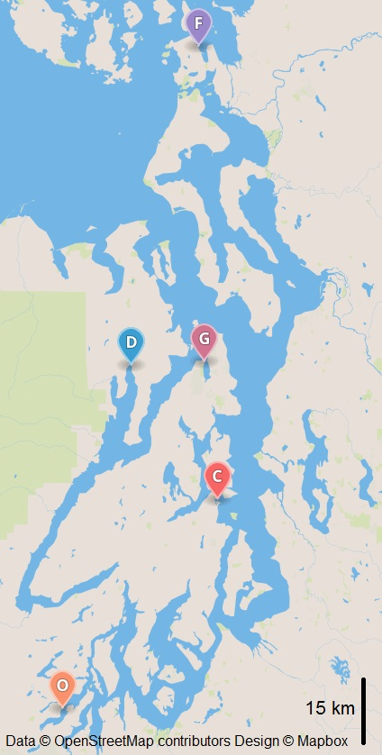

Figure 1. Map of Puget Sound with Ostrea lurida Broodstock and Outplant Sites. Conditioning site was Port Gamble (G). Broodstock collected from Fidalgo Bay (F), Dabob Bay (D), Oyster Bay (O). Outplanted at Fidalgo Bay (F), Dabob Bay (D), Clam Bay (C), Oyster Bay (O).

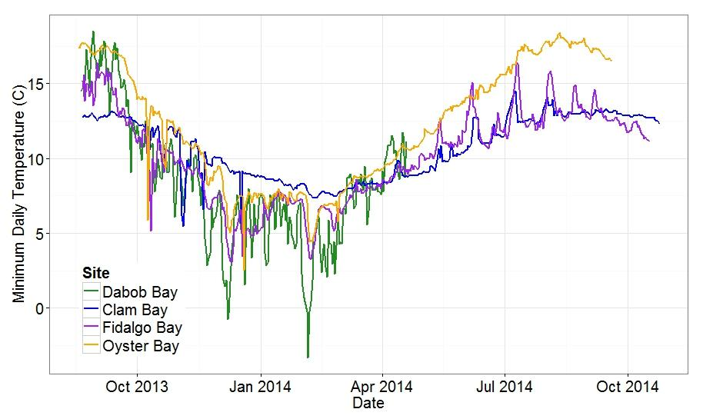
Figure 2. Minimum Observed Daily Temperatures for All Sites. Dabob Bay = Green, Clam Bay = Blue, Fidalgo Bay = Purple, Oyster Bay = Orange

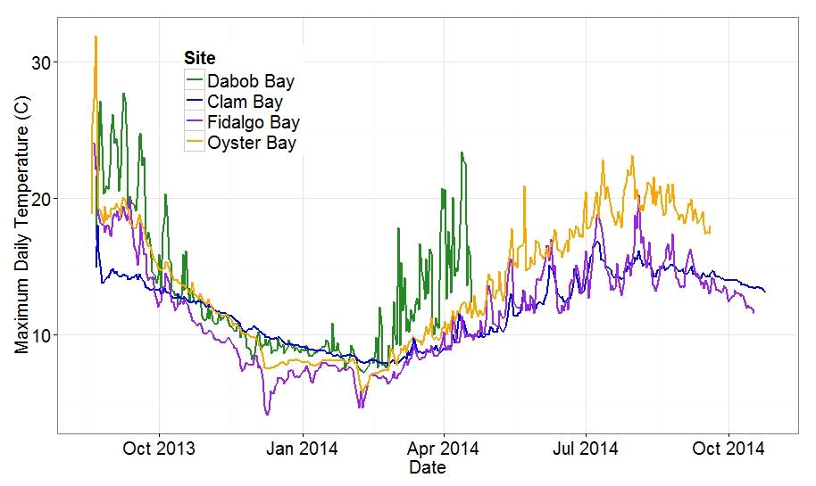Figure 3. Maximum Observed Daily Temperatures for All Sites. Dabob Bay = Green, Clam Bay = Blue, Fidalgo Bay = Purple, Oyster Bay = Orange

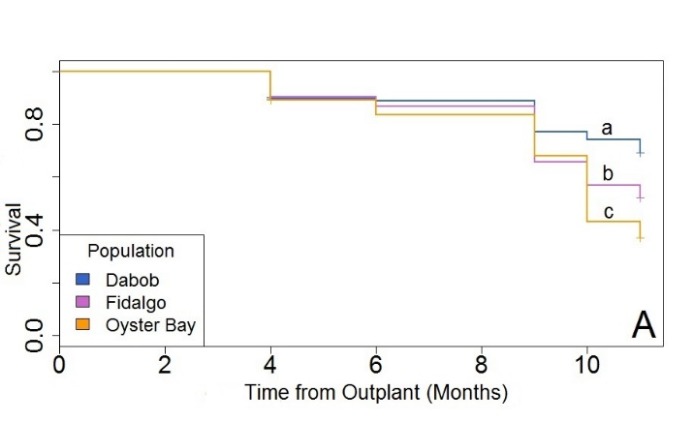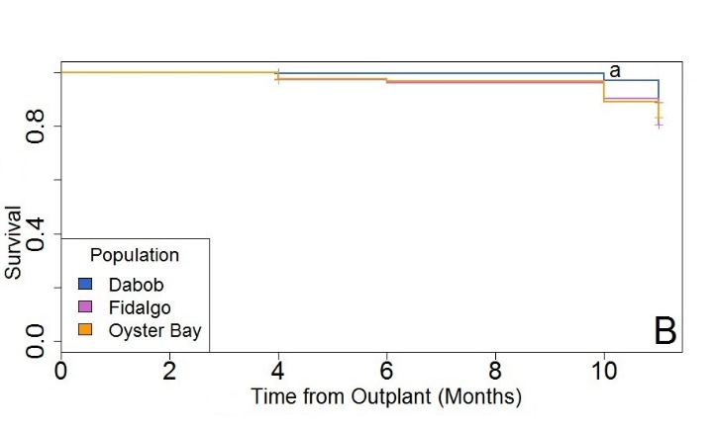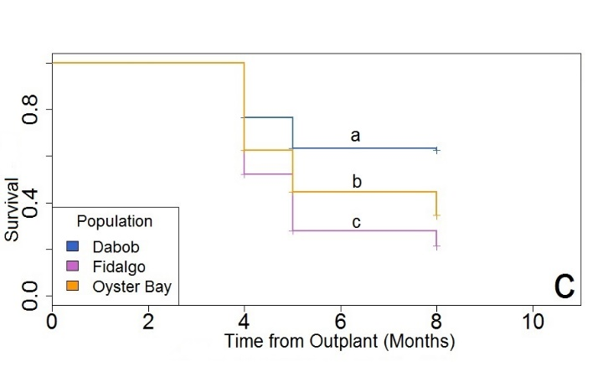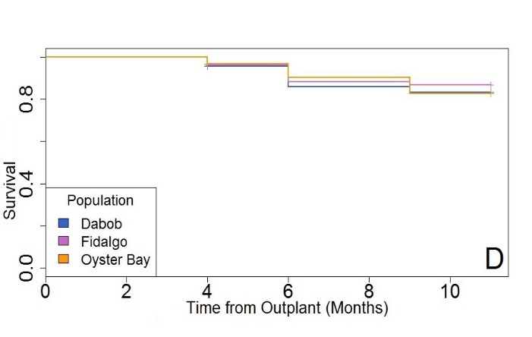
Figure 4. Proportion Survival for Three Ostrea lurida Populations. (Dabob Bay = Blue, Fidalgo Bay = purple, Oyster Bay = orange) at four locations; Oyster Bay (A), Clam Bay (B), Dabob Bay (C), and Fidalgo Bay (D). Lowercase letters (a,b,c) are significant differences.

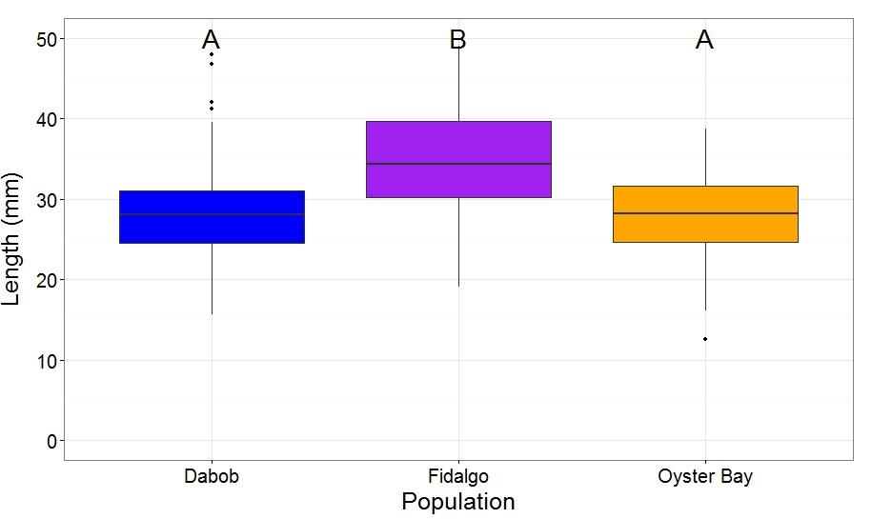
Figure 5. Ostrea lurida Shell Length in September 2014 at Oyster Bay. Boxplots with mean SL as central line and boxes represent second and third quartile. Horizontal lines are 1st and 4th quartile with dots representing outliers from data set. Letters indicate significant differences. Fidalgo Bay oysters were considered different due to Nemenyi Post Hoc test with P=0.0 (Oyster Bay and Dabob Bay oysters).

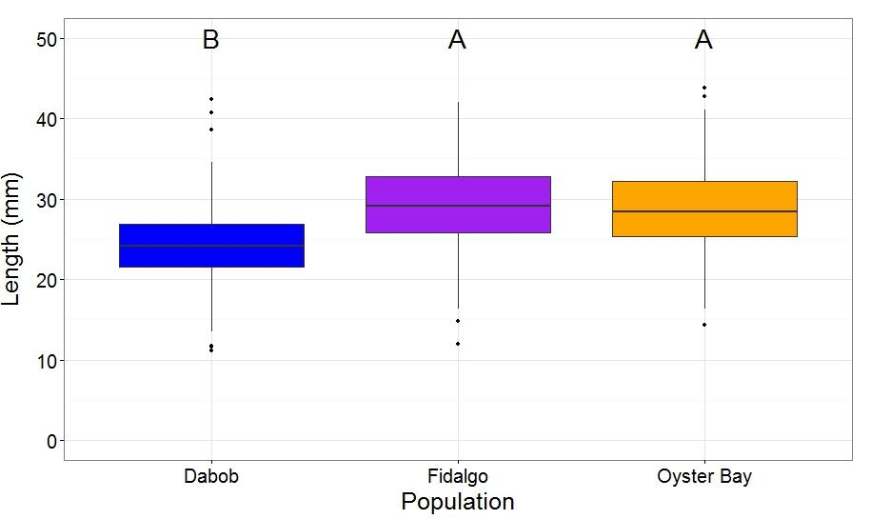Figure 6. Ostrea lurida Shell Length in October 2014 at Fidalgo Bay. Boxplots with mean SL as central line and boxes represent second and third quartile. Horizontal lines are 1st and 4th quartile with dots representing outliers from data set. Letters indicate significant differences. Dabob Bay oysters were considered different due to Nemenyi Post Hoc test with P=0.0 (Fidalgo Bay and Oyster Bay oysters).

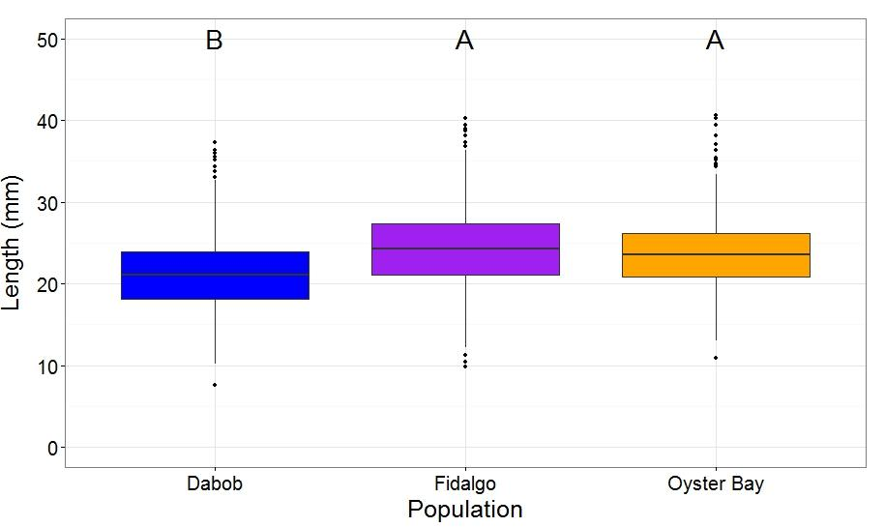
Figure 7. Ostrea lurida Shell Length in October 2014 at Clam Bay. Boxplots with mean SL as central line and boxes represent second and third quartile. Horizontal lines are 1st and 4th quartile with dots representing outliers from data set. Letters indicate significant differences. Dabob Bay oysters were considered different due to Nemenyi Post Hoc test with P=0.00028 (Oyster Bay oysters) and P<0.0001 (Fidalgo Bay oysters).

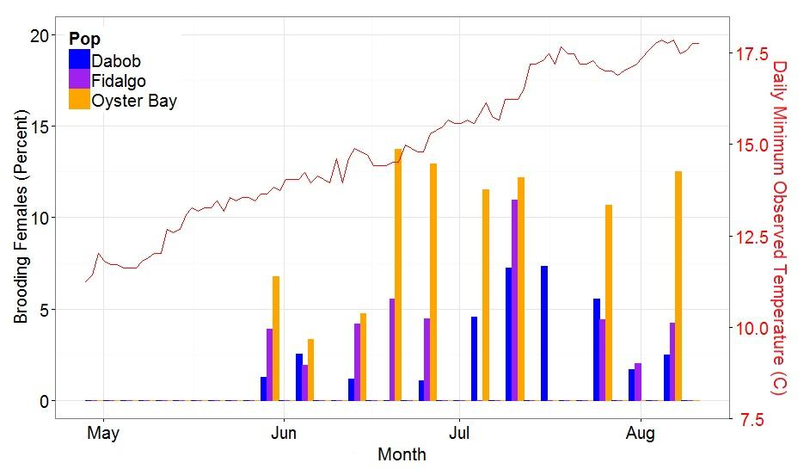
Figure 8. Percent Ostrea lurida Brooding Females from Each Population at Each Sample Date at Oyster Bay. Percent determined by number of brooding females (Br) divided by number of open oysters (T) or %=(Br/T)*100. Blue = Dabob Bay, Purple = Fidalgo Bay, Orange = Oyster Bay.

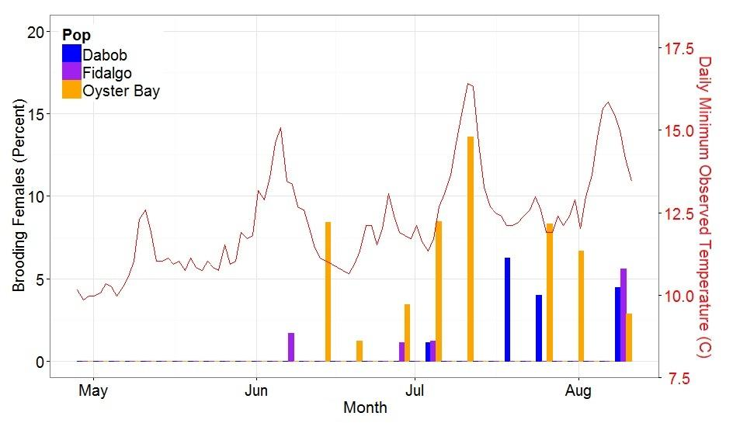
Figure 9. Percent Ostrea lurida Brooding Females from Each Population at Each Sample Date at Fidalgo Bay. Percent determined by number of brooding females (Br) divided by number of open oysters (T) or %=(Br/T)*100. Blue = Dabob Bay, Purple = Fidalgo Bay, Orange = Oyster Bay.

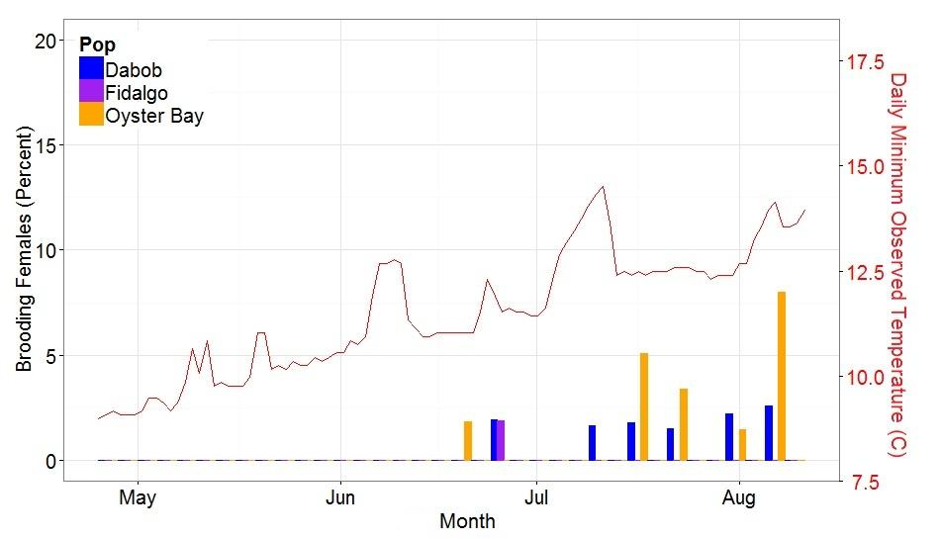
Figure 10. Percent Ostrea lurida Brooding Females from Each Population at Each Sample Date at Clam Bay. Percent determined by number of brooding females (Br) divided by number of open oysters (T) or %=(Br/T)*100. Blue = Dabob Bay, Purple = Fidalgo Bay, Orange = Oyster Bay.

